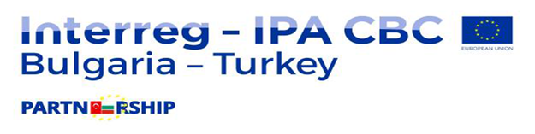
Project CB005.1.11.007 “Cross-border cooperation for preparedness and reaction in case of floods”
SUPPLIES CONTRACT AWARD NOTICE
“Supply of special-purpose equipment: mobile flood barriers and dry suit with boots for divers”
Sofia - Bulgaria

1. Type of procedure
International Open Procedure

2. Publication reference and date of the contract notice
13/02/2018, DGFSCP-FBINTL-3

3. Lot number and lot title
NA

4. Contract number and value
Contract number 198301-451, Amount 49 080.00 EUR VAT included

5. Date of award of the contract
22/05/2018

6. Number of tenders received
1

7. Name, address and nationality of successful tenderer
Eco Aqua Pure Ltd., 11 Tsar Samuil str., Sofia Bulgaria
8. Duration of contract
1 month
9. Contracting Authority
Directorate General Fire Safety and Civil Protection,
171 A Pirotska str., Sofia, Bulgaria
10. Legal basis
Regulation (EU) No 231/2014 of the European Parliament and of the Council of 11 March 2014 establishing an Instrument for Pre-accession Assistance (IPA II) and signed grant contract in frame of the program Interreg – IPA Bulgaria – Turkey Cross- Border Cooperation program No 2014TC16I5CB005-2015-1.

