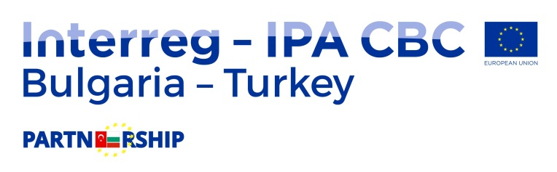
MoreCare

SUPPLIES CONTRACT AWARD NOTICE
Supply of equipment for Water Quality Monitoring in Gala Lake, Enez/Turkey

1. Type of procedure
Local open tender

2. Publication reference and date of the contract notice
16/05/2017, BG-TR/115-SUP-01

3. Lot number and lot title
N/A

4. Contract number and value
1 / BG-TR/115-SUP-01, EUR 92.121,04 /Ninety-Two Thousand One Hundred and Twenty-One Euro and Four Cents/
5. Date of award of the contract
17.07.2017

6. Number of tenders received
One (1)

7. Name, address and nationality of successful tenderer
BISOFT BILGI TEKNOLOJILERI ANONIM SIRKETI
Universiteler Mah. 1596. Cad. Safir Bloklari, No 6/C 904 kat 9
Cankaya/ANKARA
8. Duration of contract
9 months
9. Contracting Authority
District Government of Enez
Milli Egemenlik Blvd. District Government Building, 2 floor.
22700 Enez / EDIRNE, TURKEY

10. Legal basis
Regulation (EU) No 231/2014 of the European Parliament and of the Council of 11 March 2014 establishing an Instrument for Pre-accession Assistance (IPA II) and signed grant contract RD-02-29-71 / 20.03.2017 in frame of the program Interreg – IPA Bulgaria – Turkey Cross- Border Cooperation program No 2014TC16I5CB005-2015-1.

